# Software Design and Architecture



## Lab # 03

Activity Diagram in Visual Paradigm/ Lucid Chart

## Instructor: Mazhar Iqbal Email: [mazhar.iqbal@nu.edu.pk](mailto:fariba.laiq@nu.edu.pk) Course Code: CL1002 Semester Spring 2024

Department of Computer Science,

## National University of Computer and Emerging Sciences FAST Peshawar Campus

An activity diagram is **a type of Unified Modeling Language (UML) flowchart that shows the flow from one activity to another in a system or process**. It's used to describe the different dynamic aspects of a system and is referred to as a 'behavior diagram' because it describes what should happen in the modeled system.

Basic Activity Diagram Notations and Symbols

### Initial State or Start Point

A small filled circle followed by an arrow represents the initial action state or the start point for any activity diagram. For activity diagram using swimlanes, make sure the start point is placed in the top left corner of the first column.

Start point symbol - Activity diagram

### Activity or Action State

An action state represents the non-interruptible action of objects.

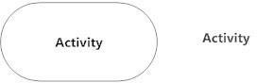

### Action Flow

Action flows, also called edges and paths, illustrate the transitions from one action state to another. They are usually drawn with an arrowed line.

Action flow - Activity diagram

### Decisions and Branching

A diamond represents a decision with alternate paths. When an activity requires a decision prior to moving on to the next activity, add a diamond between the two activities. The outgoing alternates should be labeled with a condition or guard expression. You can also label one of the paths "else."

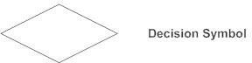

### Guards

In UML, guards are a statement written next to a decision diamond that must be true before moving next to the next activity. These are not essential, but are useful when a specific answer, such as "Yes, three labels are printed," is needed before moving forward.

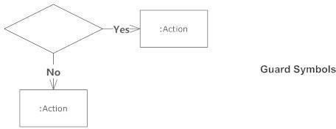

### Synchronization

A fork node is used to split a single incoming flow into multiple concurrent flows. It is represented as a straight, slightly thicker line in an activity diagram.

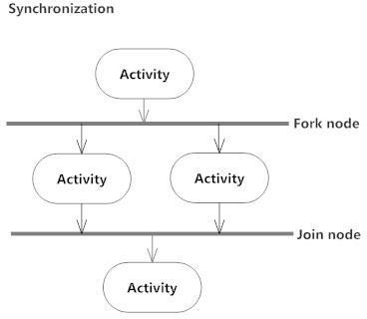A join node joins multiple concurrent flows back into a single outgoing flow. A fork and join mode used together are often referred to as synchronization.

### Merge Event

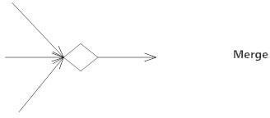A merge event brings together multiple flows that are not concurrent.

### Final State or End Point

End point symbol - Activity diagramAn arrow pointing to a filled circle nested inside another circle represents the final action state.

|  |  |
| --- | --- |
| **Notation Description** | **UML Notation** |
| **Activity**  Is used to represent a set of actions | Activity Diagram Notation - Activity |
| **Control Flow**  Shows the sequence of execution | Activity Diagram Notation - Control Flow |
| **Initial Node**  Portrays the beginning of a set of actions or activities | Activity Diagram Notation - Initial Node |
| **Activity Final Node**  Stop all control flows and object flows in an activity (or action) | Activity Diagram Notation - Activity Final Node |

|  |  |
| --- | --- |
| **Decision Node**  Represent a test condition to ensure that the control flow or object flow only goes down one path | Activity Diagram Notation - Decision Node |
| **Merge Node**  Bring back together different decision paths that were created using a decision-node. | Activity Diagram Notation - Merge Node |
| **Fork Node**  Split behavior into a set of parallel or concurrent flows of activities (or actions) | Activity Diagram Notation - Fork Node |
| **Join Node**  Bring back together a set of parallel or concurrent flows of activities (or actions). | Activity Diagram Notation - Join Node |

|  |  |
| --- | --- |
| **Swimlane and Partition**  A way to group activities performed by the same actor on an activity diagram or to group activities in a single thread | Activity Diagram Notation - Swimlane and Partition |

# Activity Diagram - Swinlane

A swimlane is a way to group activities performed by the same actor on an activity diagram or activity diagram or to group activities in a single thread.

# Swinlane Activity Diagram

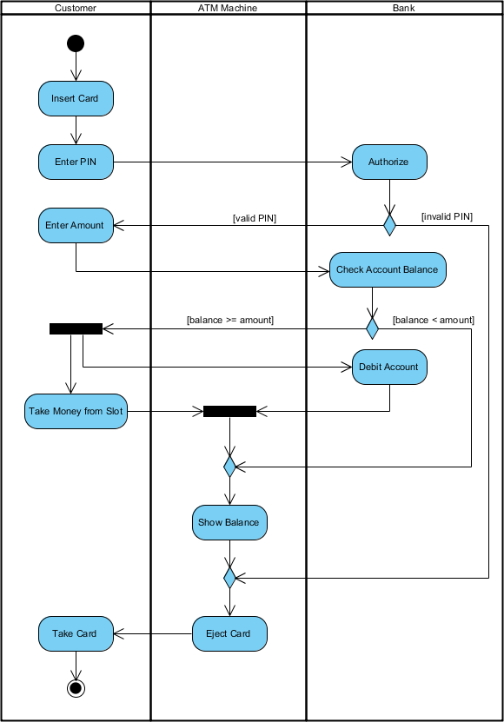

**Lucid Chart:**

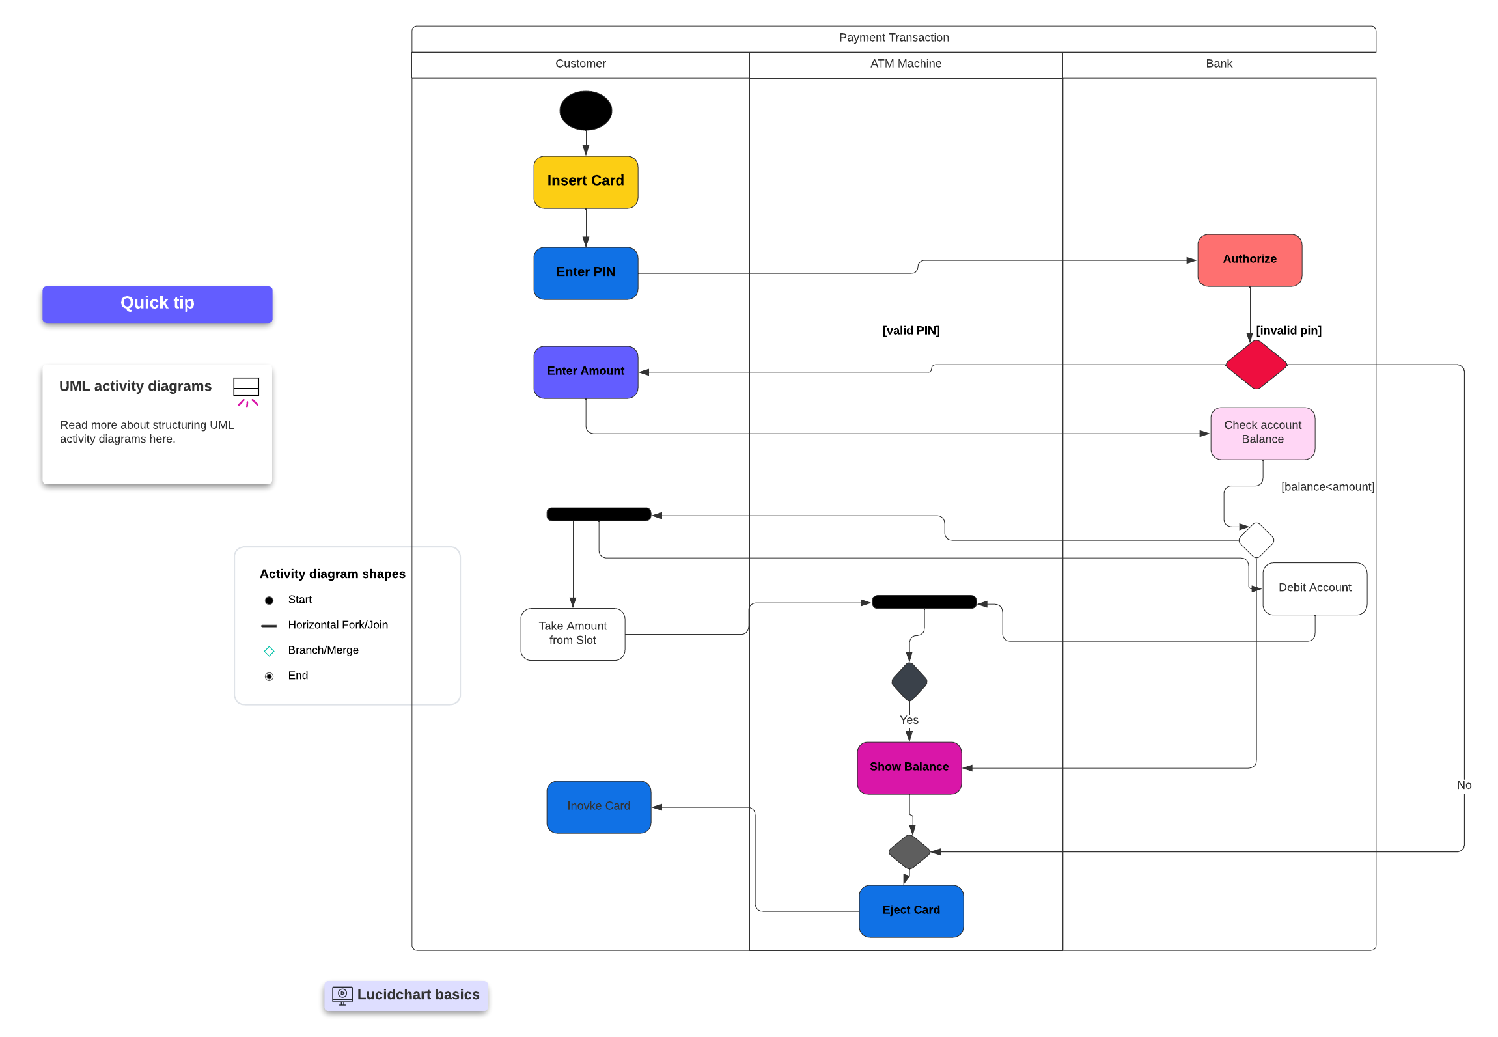

### PROCEDURE

Perform the steps below to create a UML Activity diagram in Visual Paradigm.

1. Select **Diagram > New** from the application toolbar.
2. In the **New Diagram** window, select **Activity Diagram**.
3. Click **Next**.
4. Enter the diagram name and description. The **Location** field enables you to select a model to store the diagram.

### Tool Box support for Activity Diagram

Tool box contain all the required model elements required for drawing activity diagram on the drawing panel.

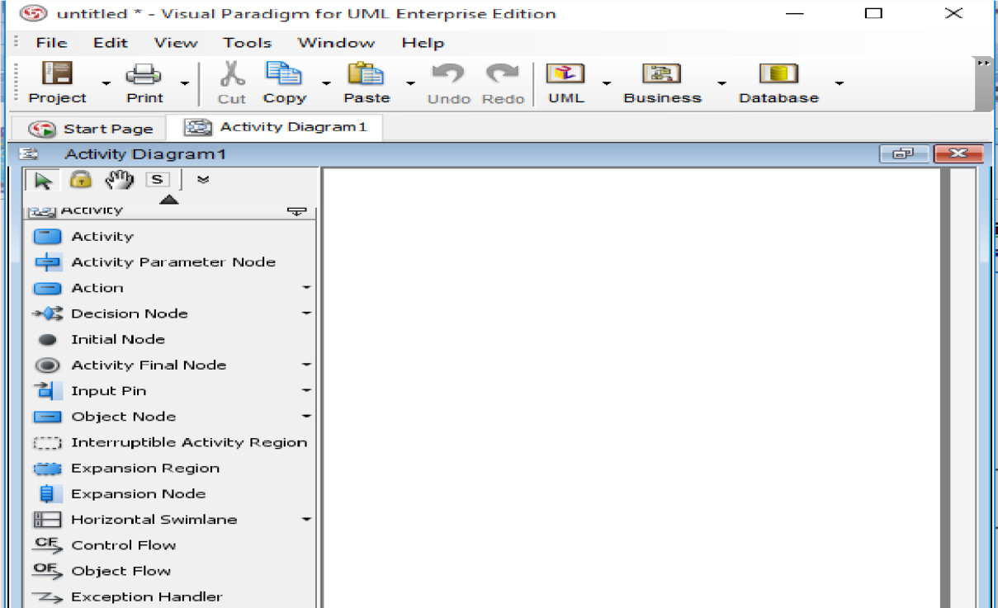

# Example Activity Diagram

## In an online shopping system, a customer searches for an item, if it is not found, he searches again, till he found a product. He adds the product in cart. After that at the same time he views the cart and can edit it. Then he confirms the order and make a payment either online using a credit card, or offline using CoD. Then the order is ships and he receives it.

